# Advance Excel Assignment 4

1. To use the ribbon commands, what menu and grouping of commands will you

find the Insert and Delete command?

2. If you set a row height or column width to 0 (zero), what happens to the row and

column?

3. Is there a need to change the height and width in a cell? Why?

4. What is the keyboard shortcut to unhide rows?

5. How to hide rows containing blank cells?

6. What are the steps to hide the duplicate values using conditional formatting in

excel?

**1. To use the ribbon commands, what menu and grouping of commands will you find the Insert and Delete command?**

Ans. So, the Insert, the Delete and the Format buttons are part of the Cells group. This group of the Home Tab ribbon holds the sixth position.To use ribbon commands from keyboard we can click on ALT BUTTON, IT WILL HIGHLIGHT the shortcut key of all the menu bar and from there we go to the **HOME MENUBAR** and then we select **CELLS GROUP,** then we can see three buttons, Insert , Delete and Format and we choose the appropriate action

So we do the following Actions

Click on **ALT→ H→** then we click on **I** for insert and **D** for delete

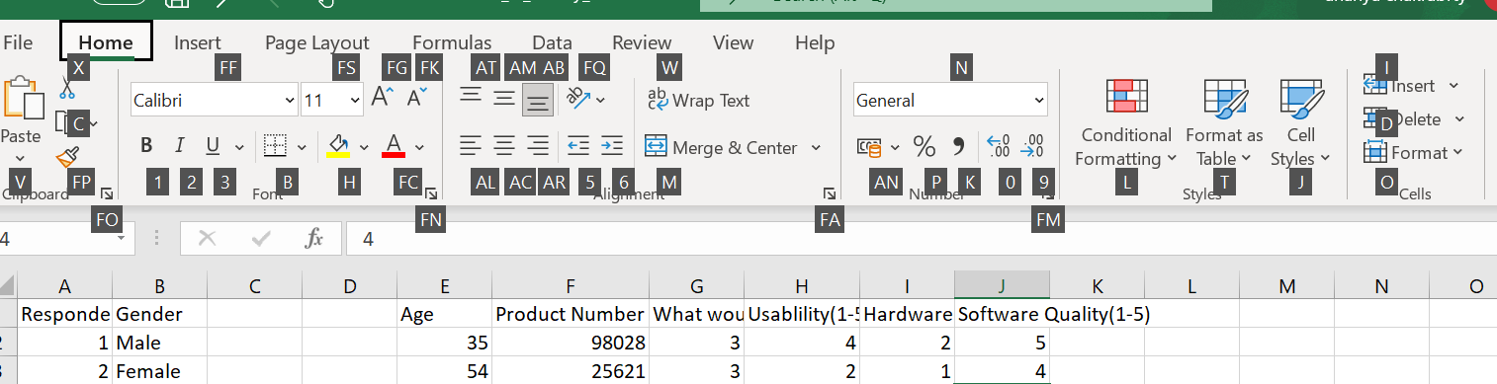

**2. If you set a row height or column width to 0 (zero), what happens to the row and column?**

If we try to set a row height or column width to 0 then the selected/row or column will be hidden by Excel.

**3. Is there a need to change the height and width in a cell? Why?**

Yes, definitely. It is important to change width and height in excel to fit the data we are entering. Excel by default provides equal width and height with respect to columns and rows. Whenever we enter a lengthy data, few characters will get displayed and others will be present inside the cell but will be hidden and thus we can adjust the height and column width in the cell.

**4. What is the keyboard shortcut to unhide rows?**

**Ans.**CTRL+SHIFT+9 is used to unhide the rows

**5. How to hide rows containing blank cells?**

Or we can select the the range that contains empty cells, Go to Home tab, go to Editing group, Click Find & Select and go to the Go To Special dialog box, select the blanks radio button and press CTRL+9 to HIDE rows

You can also select the range of blank rows you want to hide by clicking CTRL click and then click CTRL+9, or right click and select the hide rows dialog box.

**6. What are the steps to hide the duplicate values using conditional formatting in**

**Excel?**

Select the range from where you want to hide duplicates,

After Selecting, Go to Data →Select Advanced(Under Sort & Filter Group)-->The Advanced Filter Dialog Box Opens→Click on Unique Records only checkbox

Rows containing duplicate values will be hidden.